Plato’s Basics
- The world revealed by our senses is not the real world but only a poor copy of it, and that the real world can only be apprehended intellectually;
- Knowledge cannot be transferred from teacher to student, but rather that education consists in directing student's minds toward what is real and important and allowing them to apprehend it for themselves;
- Universe ultimately is good;
- Enlightened individuals have an obligation to the rest of society, and that a good society must be one in which the truly wise (the Philosopher-King) are the rulers.
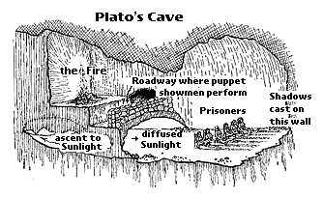
In the allegory, Plato likens people untutored in the Theory of Forms to prisoners chained in a cave, unable to turn their heads. All they can see is the wall of the cave. Behind them burns a fire. Between the fire and the prisoners there is a parapet, along which puppeteers can walk. The puppeteers, who are behind the prisoners, hold up puppets that cast shadows on the wall of the cave. The prisoners are unable to see these puppets, the real objects, that pass behind them. What the prisoners see and hear are shadows and echoes cast by objects that they do not see.

